**Signup form using Function state component**

* Create a signup form (name, age, dob, email, password, contact).

App.js

Form.js

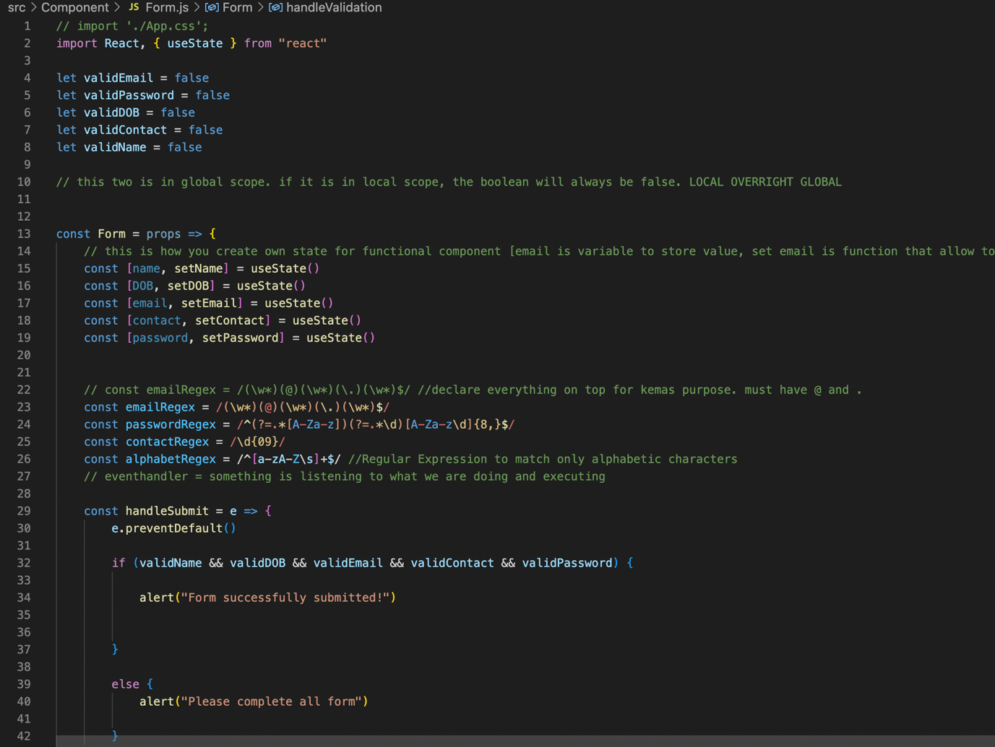

* Validate it and show the error and successful message in UI.

**Output**

Incomplete Form

Incorrect Name Incorrect Date

Incorrect Email Incorrect Password

Incorrect Contact Number

Form Successfully Submitted

